Instructions for pulling the newest version of repository from GitHub to Eclipse, version Kepler

1. When your files are not up to date, you can pull by right clicking on the project name and going to Team → Pull

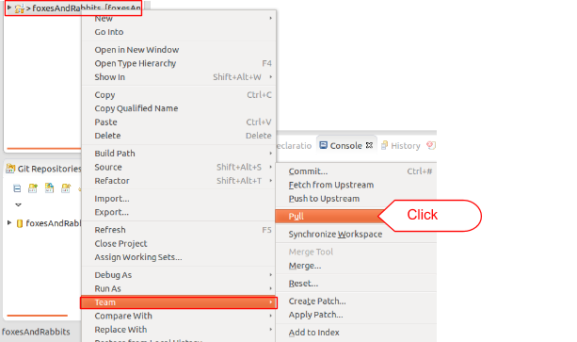

1. It will show the changes that are going to done, click “OK” and the files will be updated to the most recent changes

